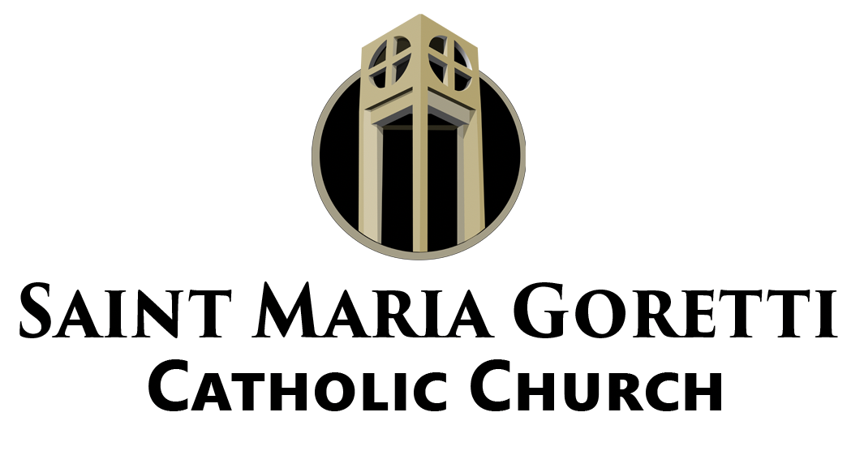

The Goretti Notes

Mass Intentions for the Week
Saturday, September 11th
4:00 PM: Michael Anthony Springer, Cynthia Bluford,
Freddie Willis, Sr., and Curtis Barriois, Sr.

Sunday, September 12th
8:30 AM: Parishioners of St. Maria Goretti
10:30 AM: Gwendolyn G. Johnson, Walter Banks, III, and Matt LeBlanc, Jr.
12:00 Noon: Kevin Joseph Hebert

Monday, September 13th: Mr. & Mrs. Charles Winchell, Sr., Clarance Bertrand,
John Fletcher, Jr. Rosita Artus, and Marilyn S.
Tuesday, September 14th: Michael Anthony Springer
Wednesday, September 15th: Audry Loredo
Thursday, September 16th: Jason David Green
Friday, September 17th: Audry Loredo
Saturday, September 18th: Narvella Chambers
Hurricane Ida
We are grateful to have you back this weekend for Masses. We know that some are still struggling with power or damages. We have listed resource centers on our website to help with finding the right place to go.

Fr. Cyril and his new parish sustained significant damage during the Hurricane. As they work to recover we are organizing a team to help them. Members of Sacred Heart in Lake Charles, who we aided last year, have offered to collaborate on this effort. As we gear up to go to bring supplies, cook a hot meal, and be a source of support we will provide information about ways to contribute. If you would like to make a monetary donation you can make it out to St. Maria Goretti and include Hurricane Ida either on the envelope or the memo line of the check. All donations will go to support our efforts to help Ascension of Our Lord and Fr. Cyril.

Recovery Resources
For a list of resources to aid in your recovery from Hurricane Ida please go to our website, smg-nola.com, and look in the News section. We have provided information from the City of New Orleans about ways to get help.

School of Religion
As families regroup to prepare for school we will reevaluate the start of our Religious Education program so that it is not a burdensome experience. For questions, please contact Mrs. Alena Boucree by email (aboucree@arch-no.org) or by phone (504) 242-7555.

Sacrament of Confession
All parishes in the Archdiocese of New Orleans will offer the Sacrament of Confession, Wednesday, September 15th from 5:00 pm until 6:30 pm. The Blessed Sacrament will also be exposed in the main Church during that time. Please mark your calendars.

Daily Mass
Just a reminder that we offer Mass daily at 8:30 am Monday through Saturday. In
order to provide space for distancing during the pandemic the Mass is offered at the main altar and not in the chapel. Consider join us for the Eucharistic Celebration. On Tuesdays, the Novena to Our Lady of Perpetual Help is prayed after Mass and on First Fridays, we pray the Novena to the Sacred Heart. Everyday before Mass a group gathers to pray the rosary. These are wonderful opportunities to encounter the Lord.

